Asia-China-Coin-3-Flat Handle-Arched Foot-H3.23 R4

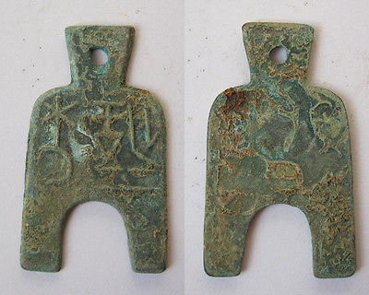

liang er jin hua FD275

[Warring States spade the original coin 041822](http://www.ebay.com/itm/161187154932)

Item price

$19.88

Quantity

1

Item number

161187154932

Shipping service

Economy Shipping from outside US

[Leave feedback](http://feedback.ebay.com/ws/eBayISAPI.dll?LeaveFeedbackShow&useridfrom=802-867&useridto=linzhoulin&item=161187154932&transactid=0) [Contact seller](http://contact.ebay.com/ws/eBayISAPI.dll?FindAnswers&frm=3998&iid=161187154932&redirect=0&requested=linzhoulin) [Return item](http://return.ebay.com/ws/eBayISAPI.dll?ResolveReturn&eventName=viewSelectedItem&TransactionId=0&ItemId=161187154932)